**Nixie clock**

|  |  |
| --- | --- |
|  | Yoren Van Vlierden |

Content

1 Introduction 1

2 Material and methods 2

3 Results 4

3.1 Nixie clock 4

3.1.1 Functionality 4

3.1.2 Basic Components 4

3.1.3 Complex Components 4

3.2 Schematics and Designs 5

3.2.1 Electrical Schematic 5

3.2.2 PCB Design 6

3.2.3 Finalized Product 8

4 Discussion 9

4.1.1 Issues 9

4.1.2 Reflection 9

5 Reference list 9

5.1.1 Datasheets 9

5.1.2 Websites 10

# Introduction

[Describe your project:

* What did you build?
* What are the main characteristics of the device?
* What does it do?
* What is the reason you chose to build this device?
* What is your starting point? Are there any (scientifically-) related articles you used?
* Give an overview of the different topics you discuss in the Application Note.

Mind your writing style: do not write: “I had to do this for the course ‘Project Design.’ Instead use objective and informative sentences using the correct tense (Simple Present). Never use subjective expressions nor personal pronouns (I, we, you). Do not address the reader. Focus on the research: describe the situation and the process.

**+/- 100 words**]

This project is surrounding the Nixieclock. It is a device that displays the current time by using 4 to 6 tubes, depending on the accuracy. If 6 tubes are used, the seconds are displayed as well. In these tubes there are 10 very thin metal electrodes that make up the different numbers. These light up respectably from 0 to 9.

The reason this device stood out is because it was one of the devices that had the most usability in daily life, and thus was an interesting device to choose. The device was found in an electrical themed magazine named: “Elektor”.

# Material and methods

[Give an overview of the materials and the methods you used:

Materials: the components for the device

* Which materials (i.e. hardware and software) did you use and did you compare?
* Which materials were not useful and why not? Use proper, objective evaluation criteria.
* Add the Bill of Materials including an indication of the price, supplier name and delivery date (table in English!)

Methods: specific tools and procedures you use to collect and analyze data (for example, experiments, datasheets…)

* Include a schematic representation (i.e. flowdiagram) and explain this representation by providing a step by step overview of the design process, production process and testing process (including a description of the mechanical design).

**+/- 500 words**]

To build this device quite a lot of components are needed. This build has around 50 components that need to be placed on a PCB. But before the PCB can be put together, it has to be designed. To do this, an electrical design program named Altium Designer was used. The program allows the user to create the electric circuit that powers and makes the device function properly. It also grants the possibility to create a blueprint for the PCB so the components can be placed on it to see what it looks like.

|  |  |  |  |  |  |  |
| --- | --- | --- | --- | --- | --- | --- |
|  | Resistors | Transistors | Capacitors | Switch buttons | IC’s | Nixie Tubes |
| Price | €5 | €1.80 | €0.20 | €1 | €27 | €70 |
| Amount | 29 | 9 | 4 | 2 | 3 | 4 |
| Delivery Date | 5-7 Days | 3 Days | 5-7 Days | 3 Days | +/- 15 Days | +/-10 Days |
| Supplier Name | Reichelt | Conrad | Reichelt | Conrad | Grandado/Reichelt | FrankTechniek |

(Bill of Materials)

All of these components play a different role in the device’s functionality. The resistors reduce the amount of current and adjust the signals as needed. Transistors are semiconductors that amplify and switch electric signals. Capacitors store electric charges in an electric field. The switch buttons can be used to change a mode of a device or set a certain value that will not change until pressed again. The ICs have different uses depending on which IC they are, the nixie tubes are the final components, they display the current time by utilising metal electrodes formed into the numbers 0-9. (cathodecorner.com)

The research of these components was aided by provided datasheets on the websites and by the database of Altium Designer.(reichelt.be)(conrad.be)(franktechniek.nl). This program showed the footprints of components. This way it became clear if they would fit on the PCB or not. This made comparing the components much easier. Besides looking at the footprint, the price and availability also had to be checked. Because there are a lot of different suppliers this can difficult sometimes. They all have different prices and delivery dates. It was recommended to use certain suppliers, but sometimes a component could be too old and thus very difficult to find at an acceptable price. Eventually, all components were found, and it was possible to start designing. in the upcoming flowdiagram the needed processes are explained.

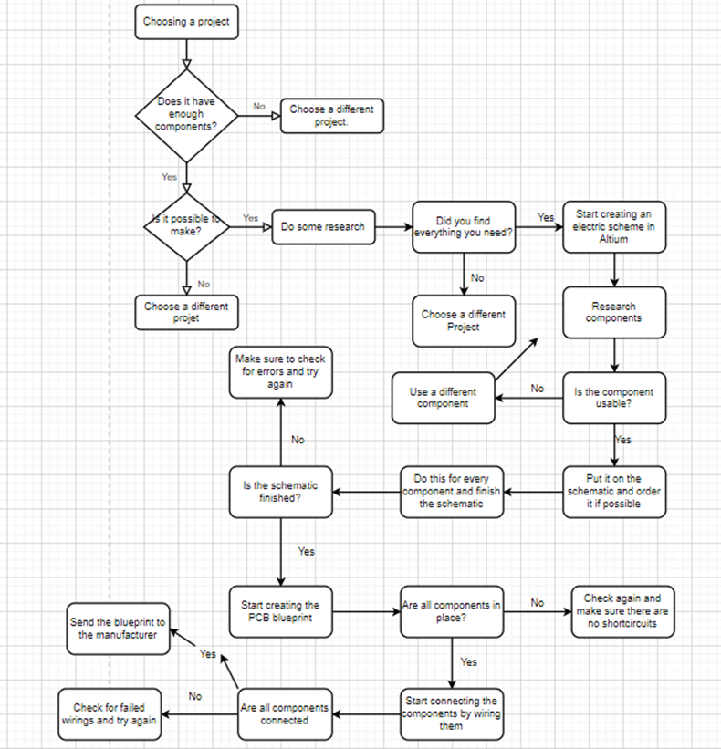(designing flowchart)

# Results

[Describe the end result you accomplished.

* Describe every aspect of your device. How does it function?
* Add an image of the electrical schematic, PCB design, finalized mechanical design, and finalized product

Write a well-structured text using subtitles and paragraphs.

**+/-500**]

## Nixie clock

### Functionality

### Basic Components

On the PCB there are many components working together to ensure that the nixie clock works properly. Each of these components has its own use and working process. In the following text all of these components and their use are explained. First of there are the more basic components like; resistors, transistors, capacitors and switch buttons. The resistors make sure that the amount of current flowing through the circuit is adjusted to the needed amount. Inside a resistor there are copper wire windings. The more windings, the higher the resistance and the more the current is reduced. ([www.explainthatstuff.com](http://www.explainthatstuff.com)). On this design there are 4 different types of resistors. The transistors serve as semiconductors and amplify the currency. The capacitor can store electricity and adjust the current even more if needed. The 2 switch buttons on the design are used to switch the modes and use a certain value until pressed again.

### Complex Components

The ICs are more complex in the way they function. The first IC is the ATTINY2313. It is a low power 8-bit microcontroller. It can do many powerful instructions in one cycle. The microcontroller is capable of one million instructions per second. Which is why it uses low power on high processing speed. For the controller to work properly it also has to be programmed. This code is obtainable from the internet. ( www.microchip.com) The DS3231 is the clock driver. It has an integrated timing crystal and temperature sensor. It is able to maintain an accurate timing even if the main power of the circuit is interrupted. It also has the ability to adjust the timing on a leap year. There was no extra coding needed for this chip as it is preprogrammed by the manufacturer(datasheets.maximintegrated.com). The final IC is the 74141 nixie driver. It is a BCD-decimal decoder, meaning it converts logic signals into decimal numbers. It is connected to the nixie tubes, and makes sure that the display is stable and doesn’t flicker. This chip does not need any additional programming either(pdf1.alldatasheet.com). The final components of the design are the nixie tubes themselves. As previously explained they display the current time by utilising metal electrodes formed into the numbers 0-9. (cathodecorner.com)

### 

## Schematics and Designs

### Electrical Schematic

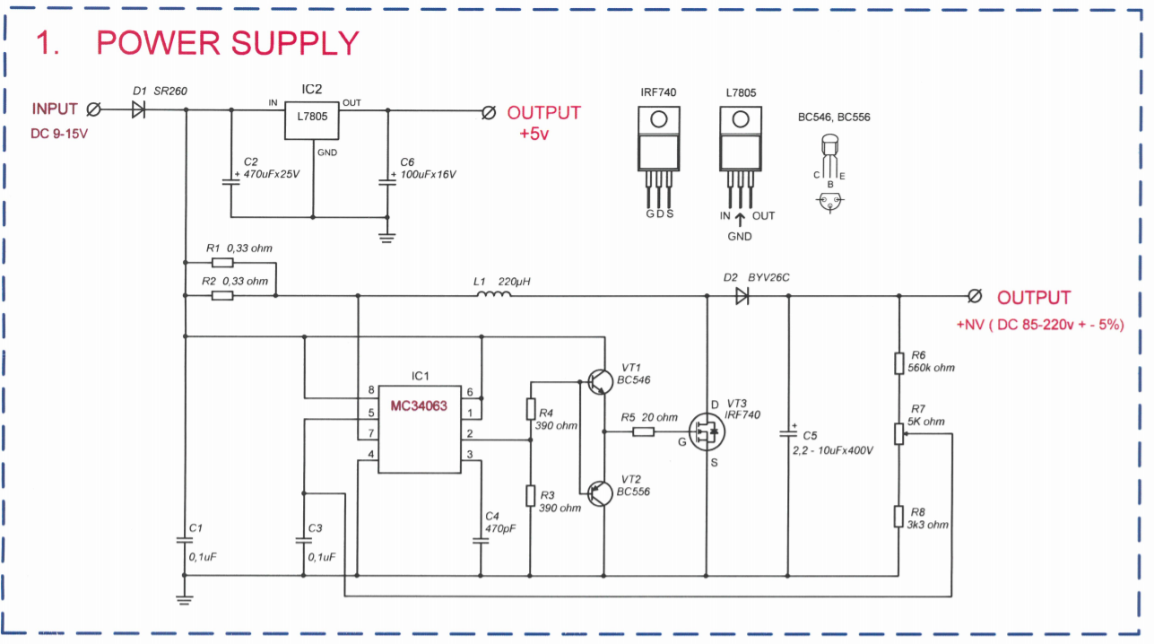

This is the Power supply of the nixie clock. Due to an error this is not included in the final design.

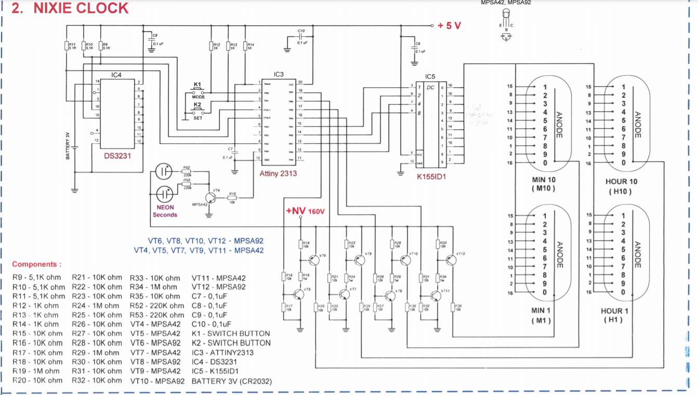

The electrical schematic of the nixie clock itself, the anodes represent the nixie tubes.

### PCB Design

The PCB Design, made in Altium Designer. The blue and red lines represent the electrical wiring inside the PCB. The squares with marked with R(number) are the resistors. The VT(number) are the transistors. C(number) represents the capacitors. And the circles are the nixie tubes.

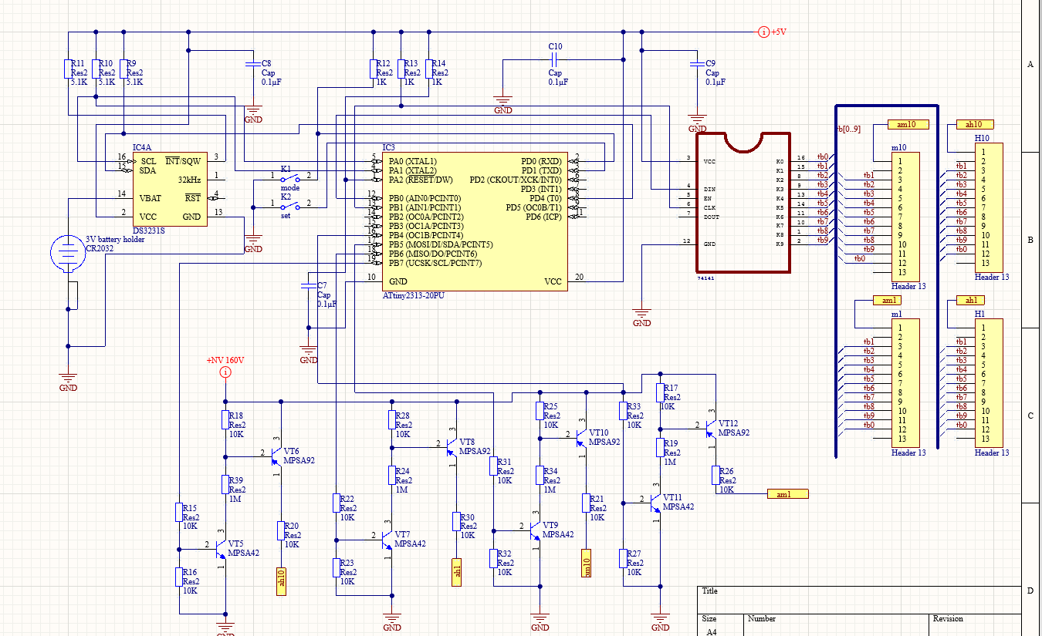

A different view of the electrical schematic, this time made in Altium Designer.

### Finalized Product

It was decided to leave the product like this, since an error in the designing process rendered the device unusable.

# Discussion

[Reflect on and discuss your project.

* Which difficulties did you encounter during the design process and why? How did you solve these issues?
* Reflect on the process: did things go as expected? Would you choose the same approach if you had to do the project all over again? Are there issues that still need to be fixed? How come?

**+/-300 words**]

### Issues

In the entire process of designing and creating the PCB many difficulties and setbacks were encountered.

Issues with finding components; one component was unfindable, so a replacement was used. The switch buttons were not correctly delivered. Instead two capacitors were delivered. So a retour was sent and the correct components were delivered a week later. In the end all components were delivered on time.

Issues during the designing process; Some of the connections were not moving over from the schematic to the PCB design. They had to be replaced with BUS-cables. Once the PCB was build it was discovered that a part of the design wasn’t included, this being the power supply. This rendered the device unusable, and so the decision was made to not solder the nixie tubes as they would be wasted.

In the soldering part of the designing process no errors occurred. The components were soldered as they should be. Nothing had to be replaced.

### Reflection

Many things did not go as planned, however the chosen approach was well planned and followed. One error that was overlooked resulted in complete failure in the functionality of the device. Due to the time this error was discovered and the lack of time that followed, this issue is not resolvable. All other issues were fixed well in time and without too much effort. Overall I am content with the entire process, considering it was a first creating something like this. The electrical scheme that was made, ignoring the missed error, was correct and well made. The placements of components on the PCB were nicely chosen and fit well. Some changes towards the next design include better checking on completeness of the schematic. All other steps were executed as they should have been.

# Reference list

### Datasheets

1. <https://ww1.microchip.com/downloads/en/DeviceDoc/Atmel-2543-AVR-Ttiny2313_Datasheet.pdf>
2. <https://datasheets.maximintegrated.com/en/ds/DS3231.pdf>
3. <https://pdf1.alldatasheet.com/datasheet-pdf/view/121942/ETC1/74141.html>

### Websites

1. Chris Woodford, Resistors, ExplainThatStuff, 2020

<https://www.explainthatstuff.com/resistors.html>

1. David Forbes, The Nixie Watch from Cathode Corner, CathodeCorner, 2011

<http://www.cathodecorner.com/nixiewatch/theory/theory.html>